CSULB – College of Engineering

Computer Engineering

Senior Design Project

CECS-490A

Dr. Pill

- Jonathan Cerniaz

- Jehmel Espiritu

- Jeremy Espiritu

- Joseph Guzman

- Afzal Hakim

- Lee Roger Ordinario

Prof:

Dan Cregg

## 

## Weekly Report 2

**Last week's list…**

Jonathan Cerniaz:

* List of potential materials for pill storage and enclosure. ✅
* Placement of object recognition. ❌
* Information on safety with certain medicines to prevent cross-contamination, crushed pills, and sanitary environment.✅

Jehmel Espiritu:

* Logistics of the pill dispensing mechanics. 🟡
* Research on motors for our design.✅

Jeremy Espiritu:

* Logistics of the pill dispensing mechanics. 🟡
* Figure out the daily medication intake for the average older adults and elderly. ✅

Joseph Guzman:

* 3D print of group-approved prototype design. ✅
* Schematics and drawings. 🟡

Afzal Hakim:

* Research on App creation for Alarm and Reminders. ✅
* Research on Data Storage for Log Tracking. 🟡

Lee Roger Ordinario:

* Improve on the design developed (such as where wires need to be/could be hidden, storage refilling, etc.)
  + Reorganized compartments to make dispensing more efficient and save space ✅
  + Halved amount of motors required to make dispensers work ✅
  + Wire management ❌

**Did you accomplish what you planned?**

This week, we completed about half of our tasks. We researched potential materials that are [Generally Recognized as Safe (GRAS)](http://www.ncbi.nlm.nih.gov/pmc/articles/PMC4590815/.) for our pill storage (ex. PLA: [Polylactic acid](https://www.geckohaha.com/what-is-pla-plasti) ), and enclosure (ex. Aluminum sheets). Additionally, we investigated the safety issues for storing certain medications, taking into consideration the possibility of [crushed medication](https://www.rosemontpharma.com/tablet-crushing/), [cross-contamination](https://www.ncbi.nlm.nih.gov/pmc/articles/PMC9047934/), potency, and [sizing](https://www.icapsulepack.com/pill-size-chart/). To optimize the design, we conducted research on the average daily [medication intake](https://www.cdc.gov/nchs/products/databriefs/db347.htm#:~:text=Among%20U.S.%20adults%20aged%2060,proton%20pump%20inhibitors%20(16.9%25) for older adults and the elderly, allowing us to create a product tailored to their needs.

Next, we explored [motor](https://www.youtube.com/watch?v=VHAqJ9a7SqI) options for our design and managed to halve the number of motors required, making the dispensers more efficient and cost-effective. We then created a 3D print of our group-approved prototype design, where we organized compartments to help visualize where everything would go. We also did research on what kind of motor we wanted for our design and we decided to use stepper motors as it is the best choice for what we want to accomplish.

**If not, why?**

We could not complete our tasks because our design is not fully complete. Since we are developing, changing, and adding to our design we still have concerns about where things would be placed. However, now that we have a 3D-printed model of our enclosure, we will be able to visualize and complete our design which would squelch all of our current concerns and confusion.

**Are all team members accounted for?**

Yes, we are all accounted for, and we are communicating consistently. We all have our assigned tasks and work together if necessary.

**Next week's plan, specific to each individual:**

Jonathan Cerniaz:

* User interface design (menus, what will be displayed…)
* How to get pills to dispense without cross-contamination
* Placement of object recognition.

Jehmel Espiritu:

* Start looking at the programming for our motor
* Figure out the motor placements for our design

Jeremy Espiritu:

* Start researching on pill sizes and weight
* Help figure out the motor placements and looking at programming for our motors

Joseph Guzman:

* Measurements
* Design, building, and placement
* Raspberry pi implementation
* Hardware connections
* Space management

Afzal Hakim:

* Start researching on how facial recognition works for sign-in.
* Start researching about the user interface for the display.
* Start researching on MySQL/Excel for data logs.

Lee Roger Ordinario:

* Figure out the dimensions of the storage compartments within the dispenser
* Figure out how objects will get to the same area for object recognition/dispense

**Pictures/Screenshots:**

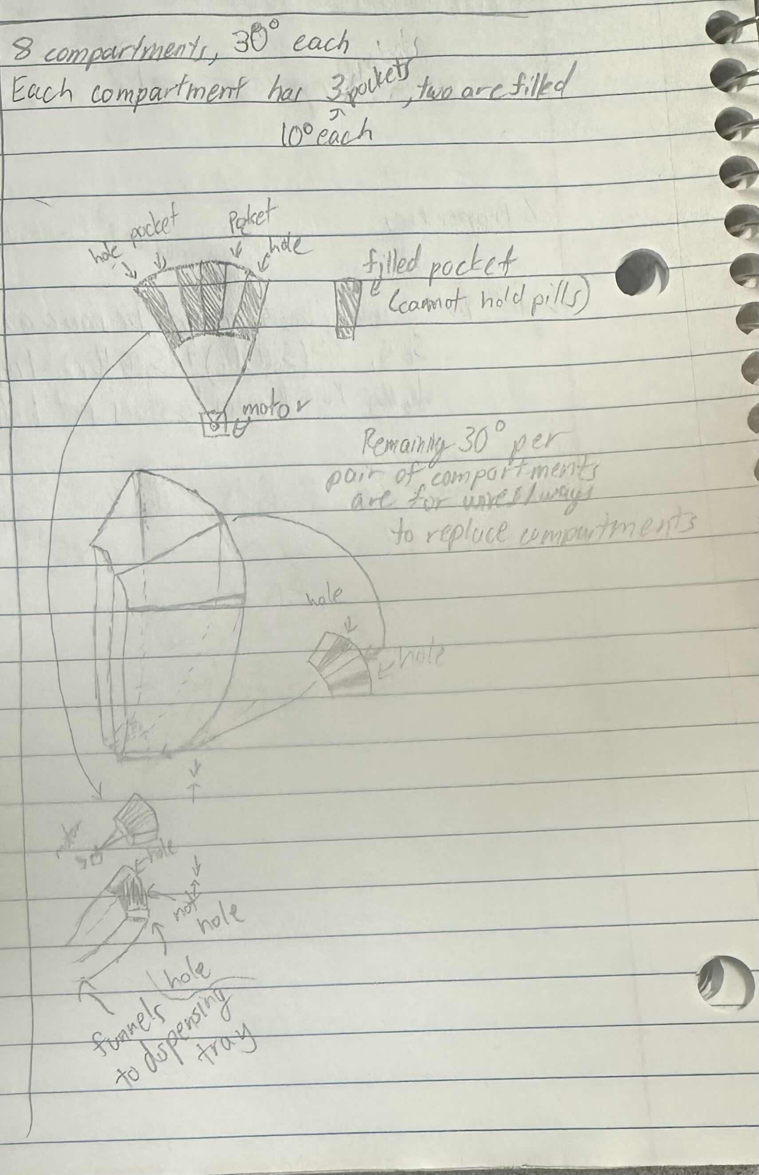

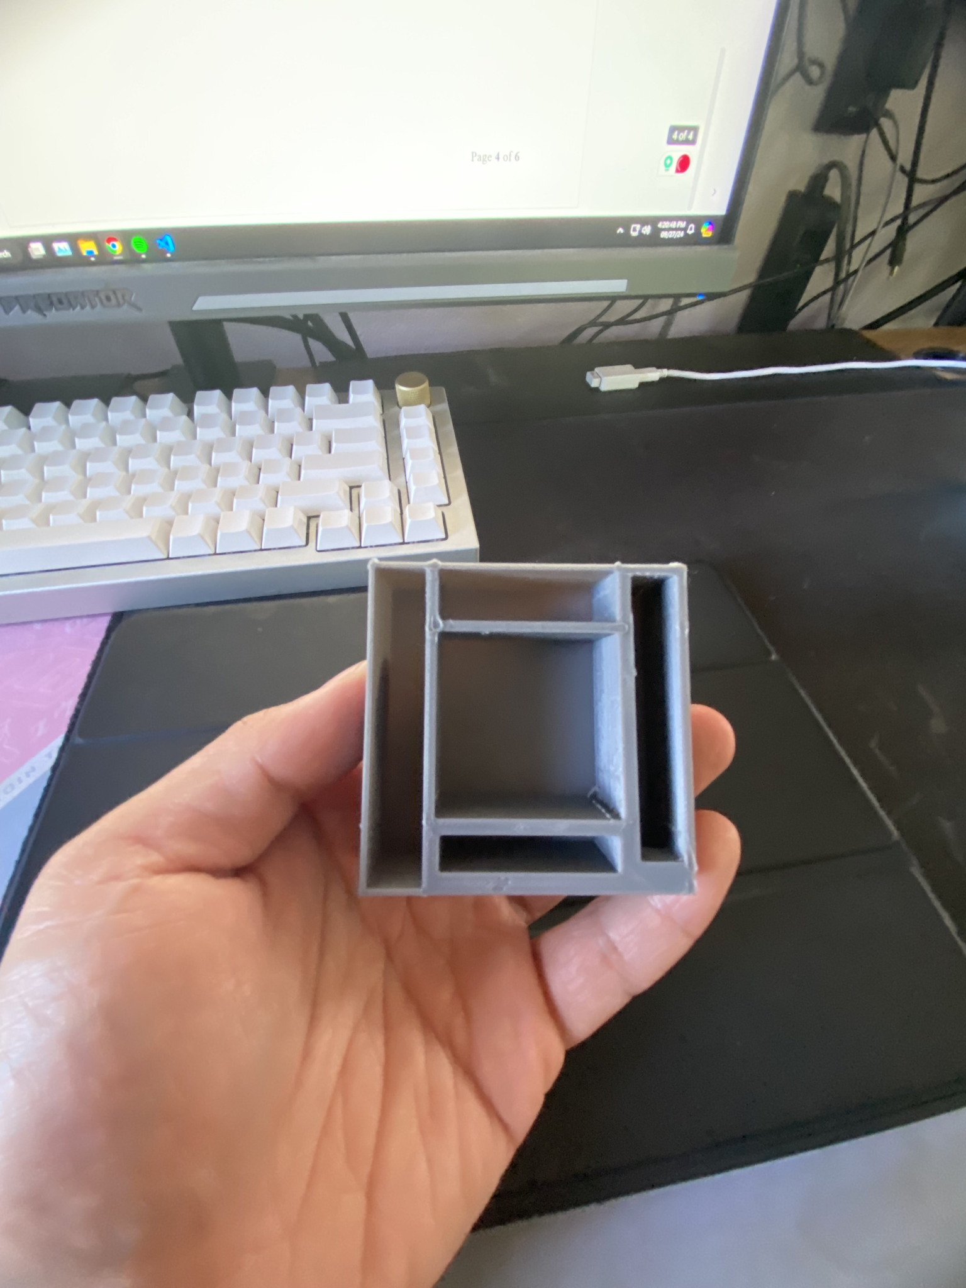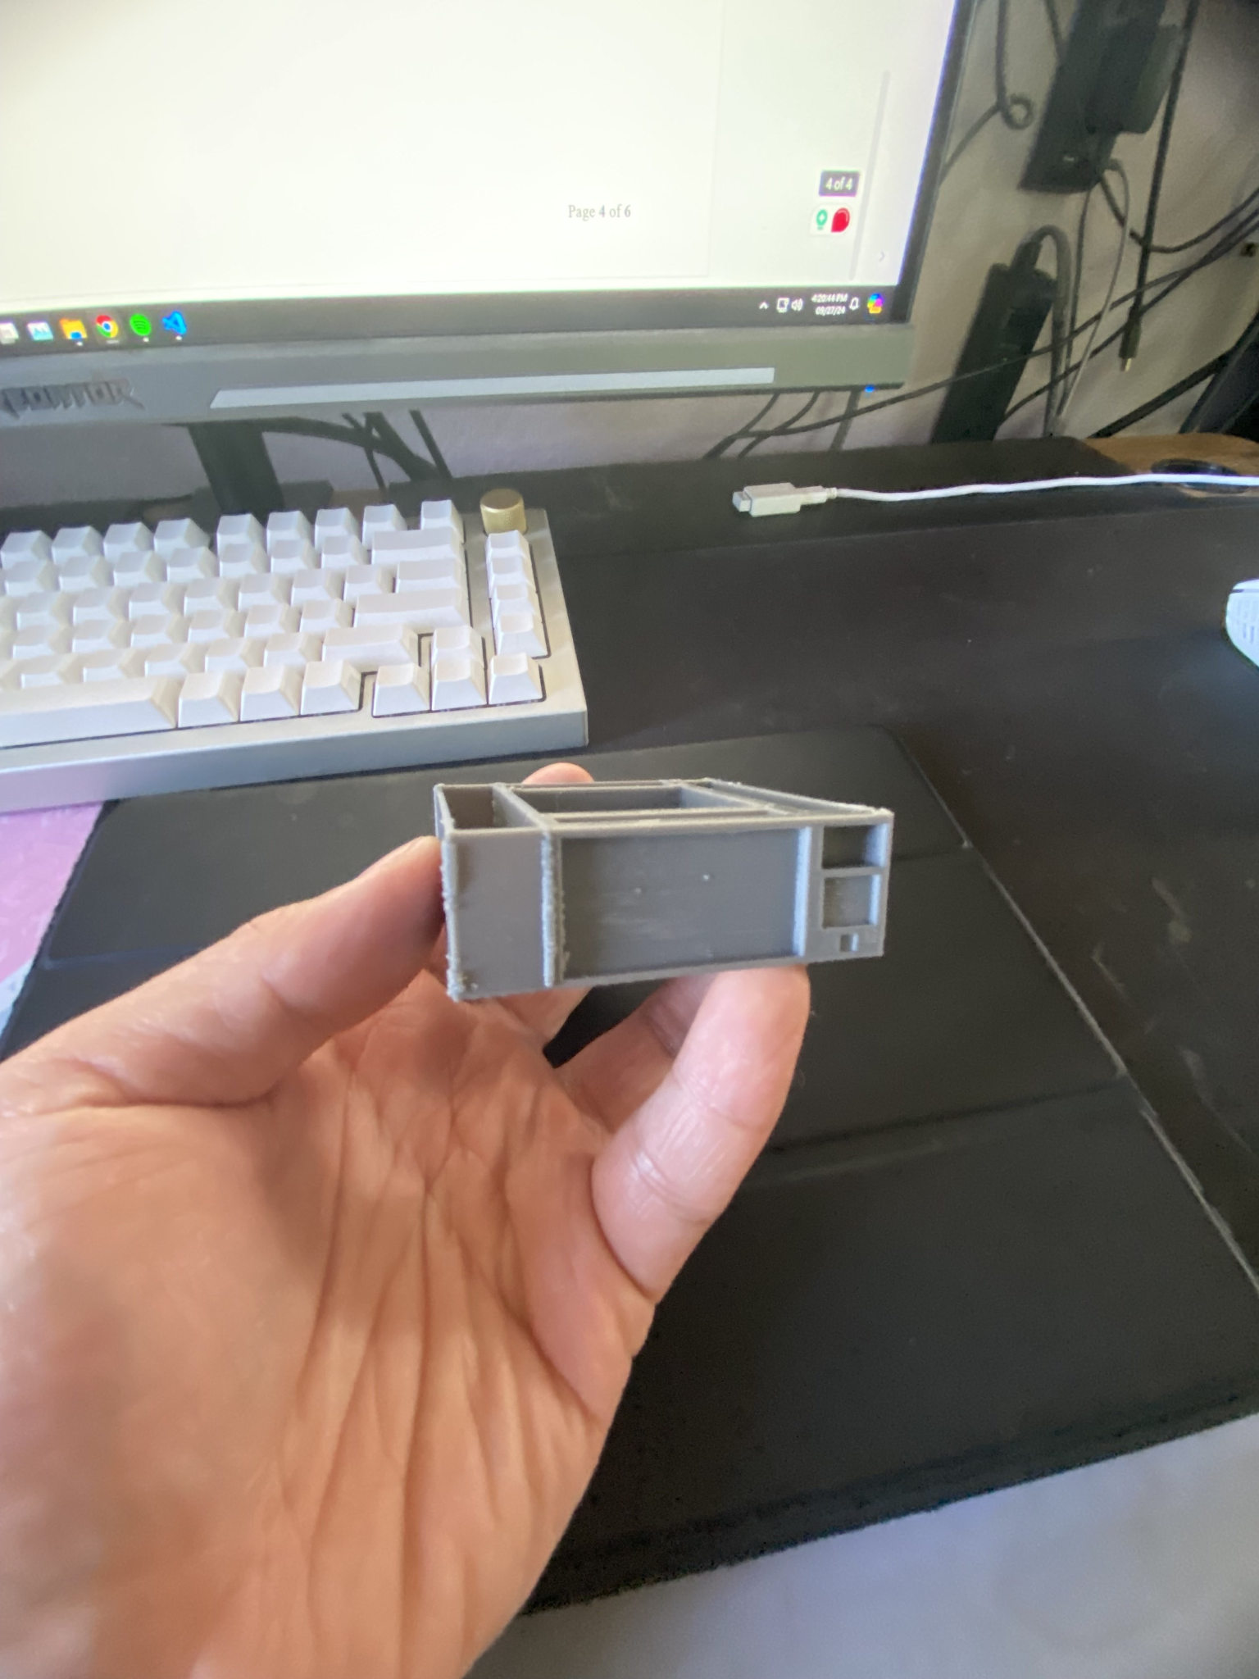

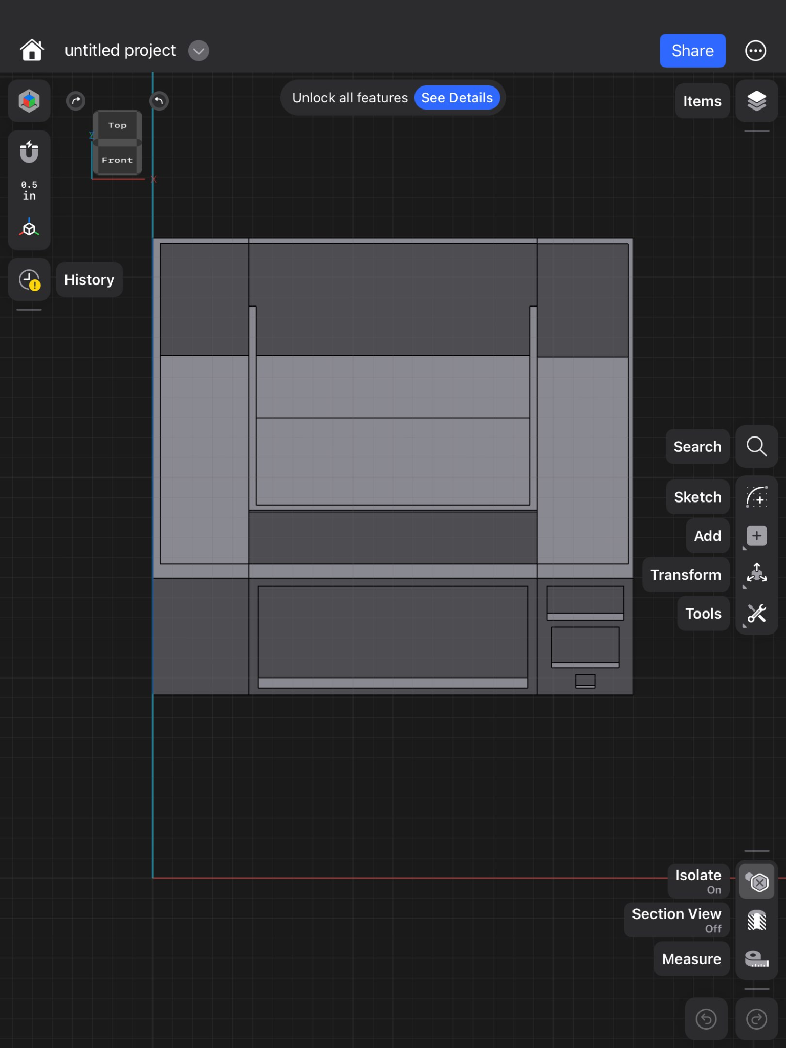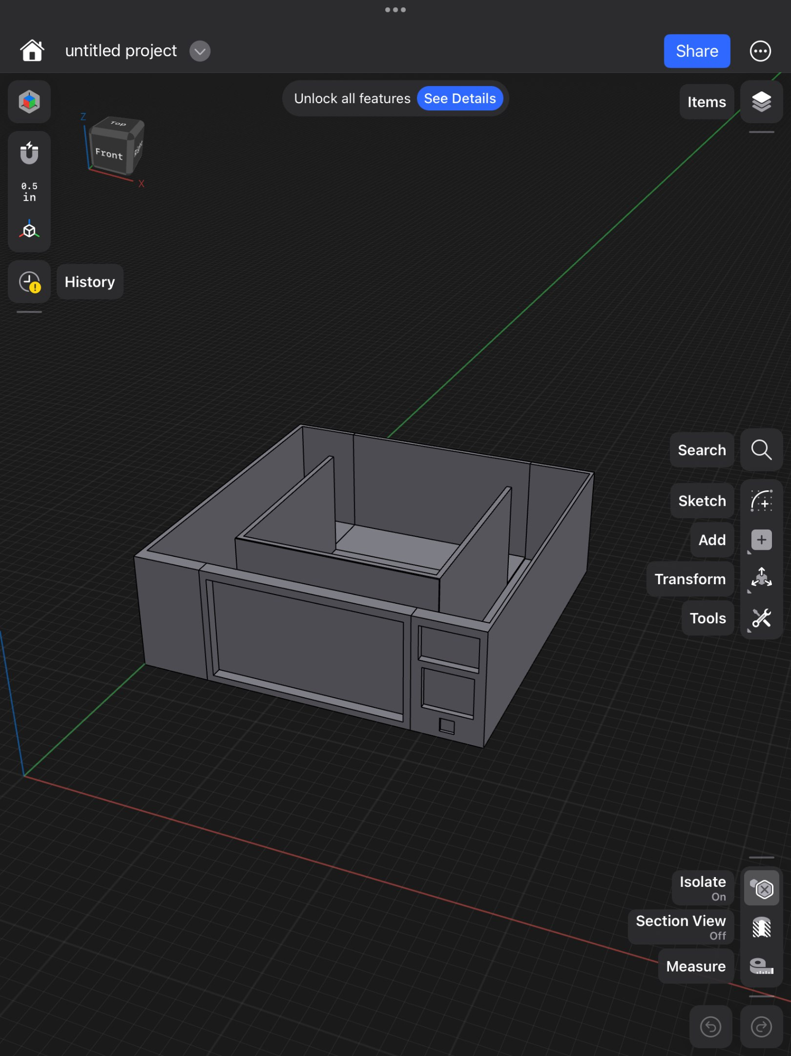

**References:**

#### *Alam, Md Tausif, et al. “FDA-Approved Natural Polymers for Fast Dissolving Tablets.” Journal of Pharmaceutics, U.S. National Library of Medicine,* [*www.ncbi.nlm.nih.gov/pmc/articles/PMC4590815/*](http://www.ncbi.nlm.nih.gov/pmc/articles/PMC4590815/)*.*

#### Alei. “Pill Size Chart.” *AIPAK*, 9 Apr. 2024, [www.icapsulepack.com/pill-size-chart/](http://www.icapsulepack.com/pill-size-chart/).

Charlesworth, Christina J, et al. “Polypharmacy Among Adults Aged 65 Years and Older in the United States: 1988-2010.” The Journals of Gerontology. Series A, Biological Sciences and Medical Sciences, U.S. National Library of Medicine, [www.ncbi.nlm.nih.gov/pmc/articles/PMC4573668/](http://www.ncbi.nlm.nih.gov/pmc/articles/PMC4573668/).

#### Craig M. Hales, M.D., M.P.H., Jennifer Servais, B.Sc., Crescent B. Martin, M.P.H., M.A., and Dafna Kohen, Ph.D., M.Sc., “Products - Data Briefs - Number 347 - August 2019.” *Centers for Disease Control and Prevention*, 14 Aug. 2019, [https://www.cdc.gov/nchs/products/databriefs/db347.htm#:~:text=Among%20U.S.%20adults%20aged%2060,proton%20pump%20inhibitors%20(16.9%25/](https://www.cdc.gov/nchs/products/databriefs/db347.htm#:~:text=Among%20U.S.%20adults%20aged%2060,proton%20pump%20inhibitors%20)

#### Ferro Uriguen, Alexander, et al. “Determination of the Cross-Contamination and Validation of the Cleaning Process for an Automated Personalised Dosing System.” *European Journal of Hospital Pharmacy : Science and Practice*, U.S. National Library of Medicine, [www.ncbi.nlm.nih.gov/pmc/articles/PMC9047934/](http://www.ncbi.nlm.nih.gov/pmc/articles/PMC9047934/).

#### Formlabs*,* “The Essential Guide to Food Safe 3D Printing.” *Formlabs*, [formlabs.com/blog/guide-to-food-safe-3d-printing/](http://formlabs.com/blog/guide-to-food-safe-3d-printing/).

#### Irfan’s Idiotic Ideas, *“How To Make A Conveyor Belt System At Home || Conveyor Belt Model || Homemade Conveyor Belt” YouTube*, [www.youtube.com/watch?app=desktop&v=8Vnoso8rhaw](http://www.youtube.com/watch?app=desktop&v=8Vnoso8rhaw).

J. Mark Ruscin, Sunny A. Linnebur, “Aging and Medications - Aging and Medications.” Merck Manual Consumer Version, [www.merckmanuals.com/home/older-people%E2%80%99s-health-issues/aging-and-medications/aging-and-medications](http://www.merckmanuals.com/home/older-people%E2%80%99s-health-issues/aging-and-medications/aging-and-medications).

#### Kohli, Venus. “Stepper vs Servo Motors: Mastering Motor Selection for Precision Engineering.” *Wevolver*, 9 May 2023, [www.wevolver.com/article/stepper-vs-servo-motors-a-comprehensive-comparison-for-your-next-project](http://www.wevolver.com/article/stepper-vs-servo-motors-a-comprehensive-comparison-for-your-next-project).

#### 

#### *Ranjit’s Embedded Solutions, “Arduino based Conveyor Belt Using DC motor with RPM Control And Object Counting”, YouTube*, [www.youtube.com/watch?v=VHAqJ9a7SqI](http://www.youtube.com/watch?v=VHAqJ9a7SqI).

#### *Rosemont Pharma,* “Rosemont: Information For Patients On The Dangers Of Tablet Crushing.”, 14 Oct. 2023, [www.rosemontpharma.com/tablet-crushing/](http://www.rosemontpharma.com/tablet-crushing/).

#### Wang, Nathan, “What Is PLA Plastic? Benefits, Uses, and Safety of PLA Material!” *Onenice Internaional Co., Ltd.*, 30 July 2024, [www.geckohaha.com/what-is-pla-plastic/](http://www.geckohaha.com/what-is-pla-plastic/).

#### 